11 The Projects Page

Contents

Turn on Sass 1

Creating the Project Page 1

Copy the About Page and Paste into the Project Page 2

Create the SASS Partial File 8

# Turn on Sass

In Visual Studio

Remember to turn on your Watch Sass



# Creating the Project Page

We want to create a new file inside of the dist folder.

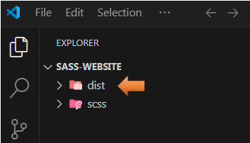

Create a new file

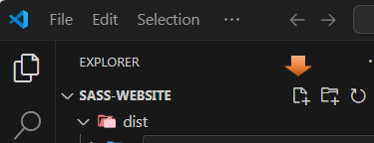

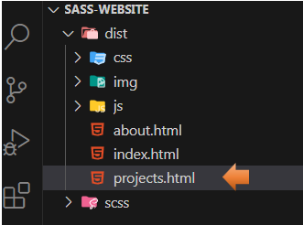

# Copy the About Page and Paste into the Project Page

We are just going to do a copy and paste from the last html page that we made, in order to have a starting point for the project page.

Start out by changing the title on the new project page to reflect this page

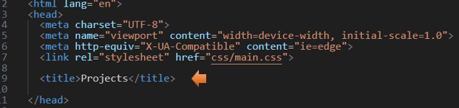

Take the active and place it on the project link.

*Watch it, make sure active is placed inside of the quotation marks and not outside of it.

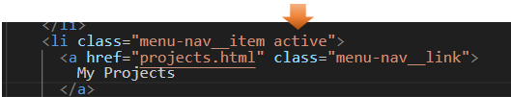

Test the Menu

You can test the page now by clicking on the hamburger menu and making sure that the project link is indeed showing up in our highlighted color.

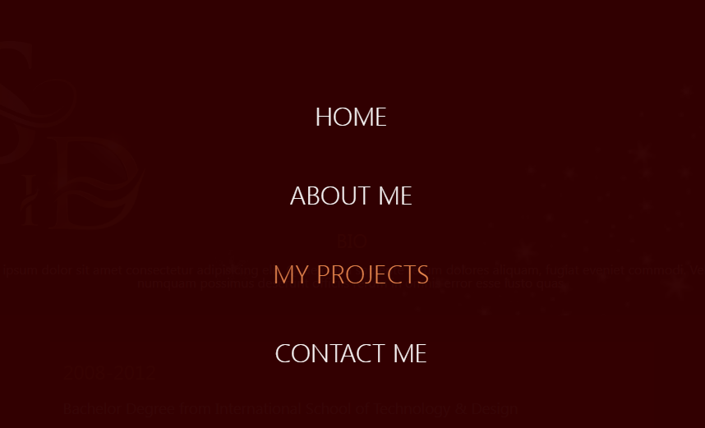

Make changes to the Class Names

Go inside of the main and then rename the section to be the class of projects.



Rename that first div to be a class of projects__bio-image.

Delete that inside div with the text that was in it.

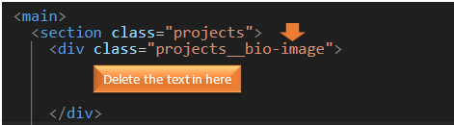

Insert text

Where we deleted the text, we will add an h1 tag

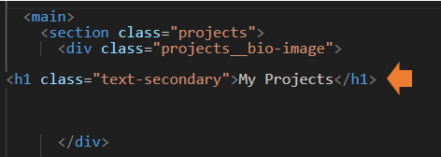

Remove all of the Jobs

We want to remove all of the code that will place the jobs on the page

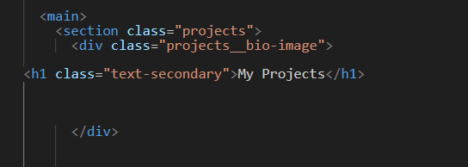

Test the Page

If we look at the page now it will look like this.

*Remember, since we changed the section to have a class of projects, we do not have very much in the way of styles…Yet.

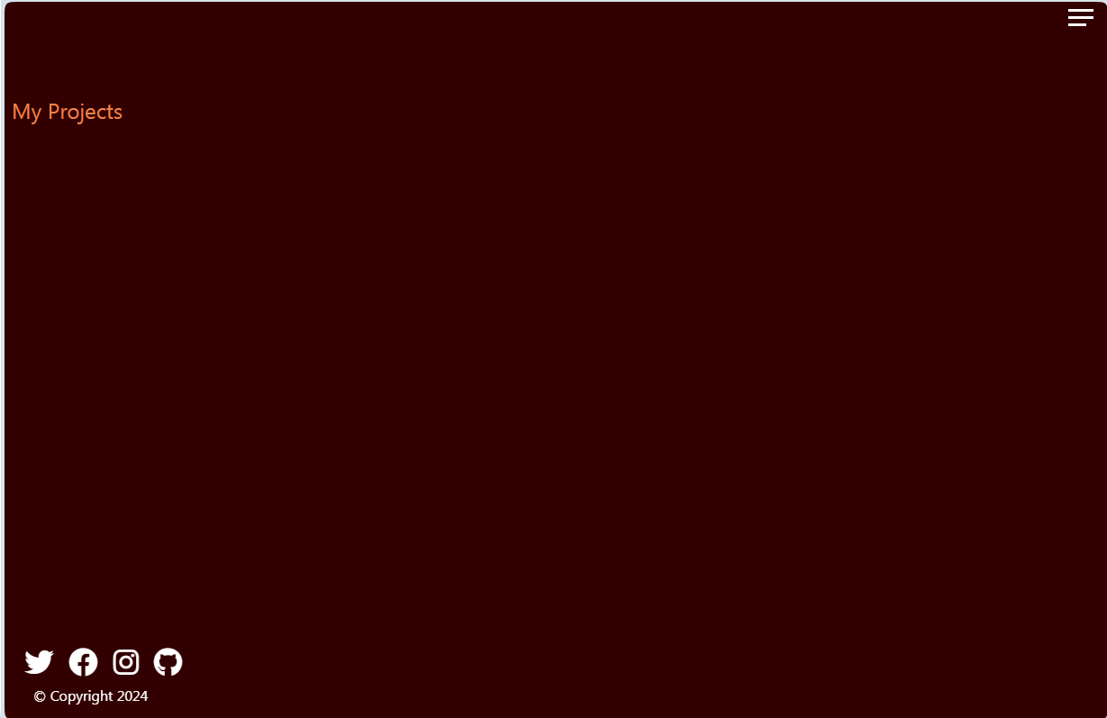

Create the div for project items and projects item

We want a div to hold all of the items, so notice the added s at the end in the outer div, and then an inner div to hold each item.

<main>

<section class="projects">

<div class="projects__bio-image">

<h1 class="text-secondary">My Projects</h1>

</div>

<div class="projects__items">

<div class="projects__item">

</div>

</div>

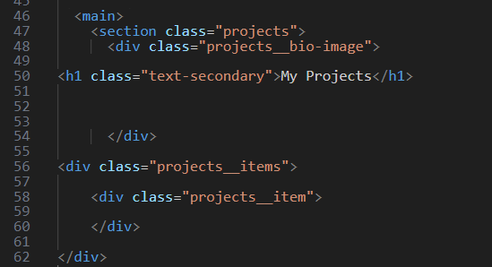

To Create the items

<div class="projects__items">

<div class="projects__item">

<img src="img/project-1.jpg" alt="My Project">

<div class="projects__btns">

<a href="#!" class="projects__btn">

<i class="fas fa-eye"></i> Preview

</a>

<a href="#!" class="projects__btn">

<i class="fab fa-github"></i> Github

</a>

</div>

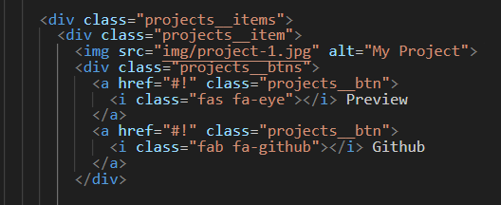

Now we want to copy that particular code 5 more times and then change each number to the image.



Testing

If you test it now, since we have no real styling, everything will come in full size and huge.

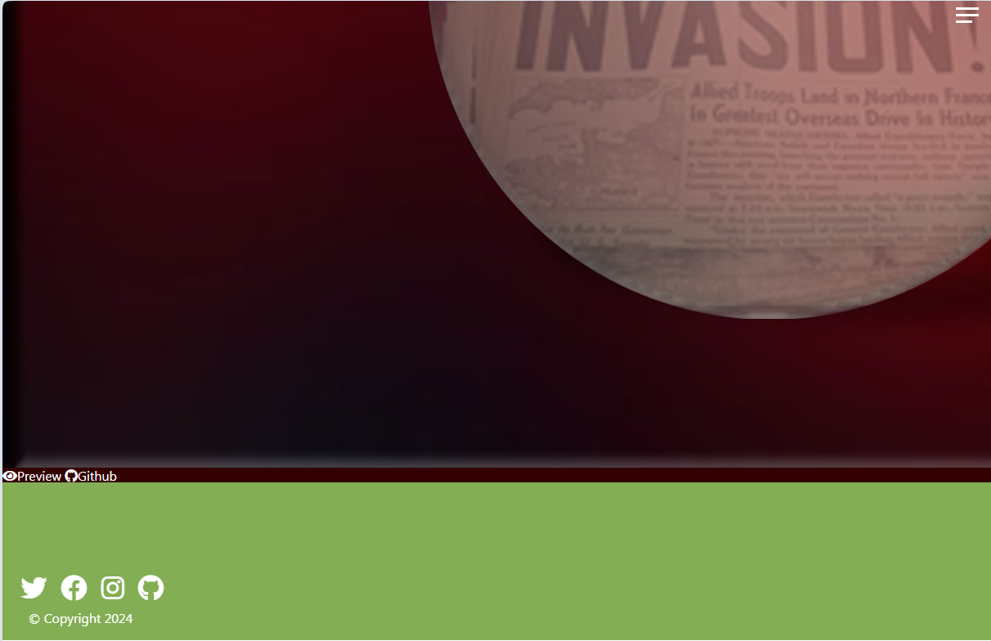

# Create the SASS Partial File

Inside of the scss folder, create a new sass file.

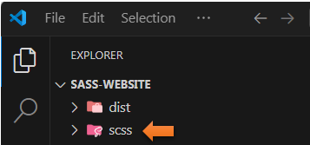

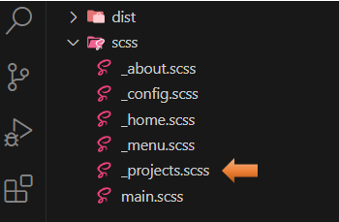

Go to the main.scss file

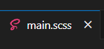

Import the partial projects.scss file up at the top of it.

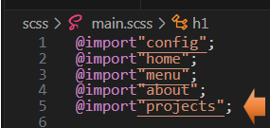

Take the About.scss, and copy and paste it into the project.scss

There will only be a few changes between these two files, so we can start off will a copy of the about.scss file.

Change the class name to be .projects from about

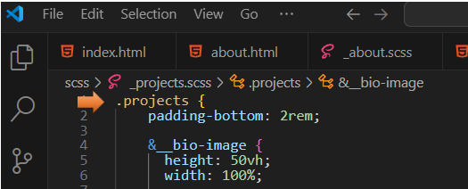

Change the height to be 60vh

This height thing will depend on your own image and what you want displayed, but I changed this to 60vh, because I found that my Logo did not show all of the way at a shorter height, when full screen. I am leaving this mistake in on purpose, because tracking down the cause of your mistakes is important, and even the professionals will still make them.



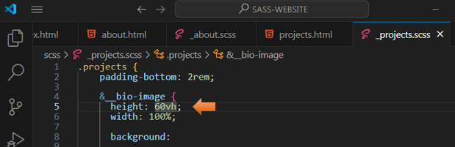

This change will need to be made on the about.scss too.

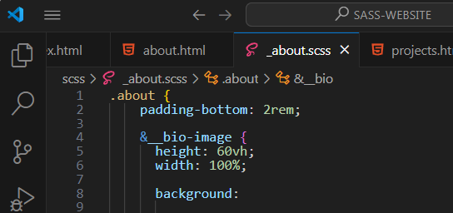

Now the SD Logo fits inside of the header.



Scroll down until you find the p rule.

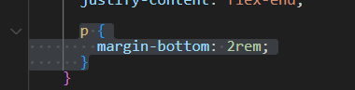

Write this rule in where that p tag was at

.text-secondary {

font-size: 2 rem;

margin-bottom: 2 rem;

}

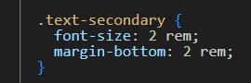

We want to remove this code here

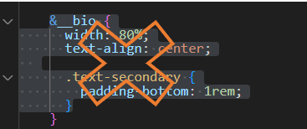

Change .jobs rule to &__items

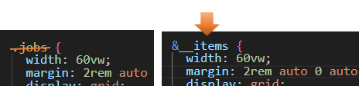

Remove the &__jobs Section

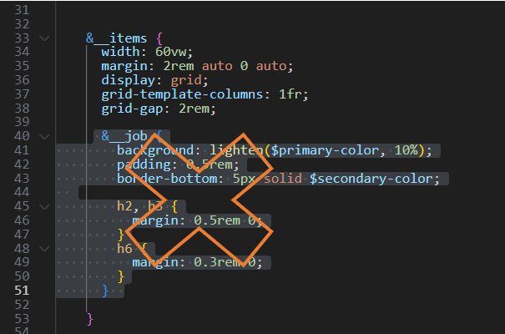

&__items {

width: 60vw;

margin: 2rem auto 0 auto;

display: grid;

grid-template-columns: 1fr;

grid-gap: 2rem;

}

&__item {

position:relative;

border-bottom: 5px solid $secondary-color;

overflow:hidden;

cursor:pointer;

img {

width: 100%

}

}

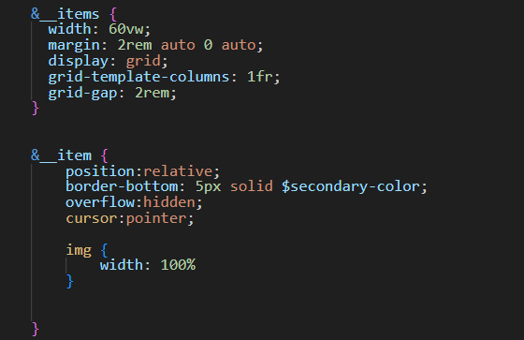

Testing

